Pyramid in dart

Exercise #1

Flutter Developer Bootcamp

# **Purpose**

This exercise demonstrates how to generate a pattern using nested loops and print it to the console. The pattern resembles a pyramid shape made of stars (*), with each row having an increasing number of stars from the top row (which has one star) to the bottom row (which has five stars). The stars are separated by spaces for better visualization and clarity.

**Problem**

This exercise demonstrates fundamental concepts such as nested loops (for loops), string manipulation, and pattern generation. It's a common exercise to reinforce understanding of loop control, string concatenation, and structured output formatting in programming languages. The pattern generated resembles a pyramid made of stars, demonstrating how to use nested loops effectively to achieve structured output in Dart.

**How to Solve**

1. Checkout the Exercise from Git Repo:

git clone -b <user-branch> <repo-URL>

2. Open the root folder inside VS Code

3. Open the root folder in terminal

4. Run the command dart run filename.dart

5. It utilizes nested for loops to control the structure and content of each row in the pyramid pattern.

6. The first inner loop adjusts the number of leading spaces based on the current row (i), creating a pyramid indentation effect.

7. The second inner loop appends stars (*) to stars string, gradually increasing the number of stars with each subsequent row.

8. This approach demonstrates effective use of loops and string manipulation to generate structured patterns in Dart.

9. Go To File: <specific-file-with--method> à <method-name>, implement your logic.

**You will Achieve**

When you complete this exercise you will learn the following:

* **Pattern Generation:** Constructs a pyramid pattern using stars (*) and spaces.
* Starts with fewer stars at the top and increases the number of stars towards the bottom, forming a pyramid shape.
* **Loop Control:** Demonstrates the use of nested for loops to control the structure of the pattern.
* The outer loop (i loop) manages rows, while inner loops (j loops) manage spaces and stars within each row.
* **String Manipulation:** Utilizes string concatenation (+=) to build each row (stars string) by appending spaces and stars.
* **Output Display:** Prints each row of the pattern to the console using the print() function.
* Each print(stars) statement outputs a single row of the pyramid pattern.

**Methods and Functions Used:**

* **main() Function:**
* Entry point of the Dart program.
* Orchestrates the execution of the code.
* **print() Function:**
* Used to display output to the console.
* Prints each row (stars string) of the pyramid pattern.
* **String Concatenation (+= Operator):**
* Combines and builds the stars string by appending spaces and stars iteratively.
* **for Loop:**
* Used for iteration and control flow.
* The outer for loop manages the number of rows (i loop).
* Inner for loops manage the number of spaces (j loop for leading spaces) and stars (j loop for adding stars).

# **Screenshots**

## **Expected output (Pyramid)**

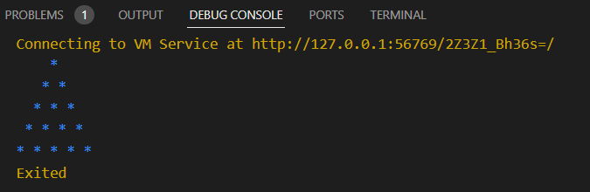

# **How to submit your exercise**

Push your project back to the same git branch using command:

<command name>

# **Happy Coding!**